

**Blount County Memorial Museum**

**Press Release**

*For Immediate Release*

***Contact Person: Amy Rhudy***

*Curator, Blount Memorial Museum*

*Telephone Number: 205-625-6905*

*Email Address: curator@blountmuseum.org*

*Website Address:* [*www.blountmuseum.org*](http://www.blountmuseum.org)

HEADLINE: Blount Memorial Museum Web Site Has A New Look

Oneonta, June 5 2016 — The Blount County Memorial Museum has an updated web site with a greatly improved new look and feel. There’s a handsome background, well-placed images and snapshots, as well a views of the museum’s displays. There’s also descriptions of the Blount County’s heritage and history and a summary of recreational activities. A second voluntary genealogist now is available, and all material is readily accessible from a set of menu tabs that is displayed on every page.

Also, there’s inclusion of the key forms used by the museum staff and its patrons – release forms, order forms for items for sale at the museum, and an online member application form for the Blount County Historical Society. The links page has been greatly improved, and weaves all the Counties major web sites together in one location. It also identifies the web sites of the Museum’s major sponsors and supporters. The schedule of activities and programs that the Museum provides is also updated and provides a comprehensive list for the current calendar quarter, as well as of the more important events throughout the current calendar year.

“This is something that’s been long overdue, and we were fortunate to have a volunteer show up and offer to help with the web site. I’m really excited over the range of possibilities this opens up for us to better fulfill our mission here”, was the reaction of the Curator, Amy Rhudy, when she first saw the first pages proposed by the new webmaster. “ I feel as though I’m really in the big leagues, now!”

Continuing, Amy mentioned that the Museum is always eager to receive stories and family lore, as well as artifacts and relics pertaining to the Counties history and/or heritage. It also can use more volunteers, and any assistance would be greatly appreciated, both by the Museum staff and the Museum’s patrons.

The Museum is open from 8:00 – 5:pm, Tuesday through Thursday each week. Viewers may browse the site at <http://www.blountmuseum.org>. and all the major browsers work with the updated site.

+ - + - +

**Addendum**

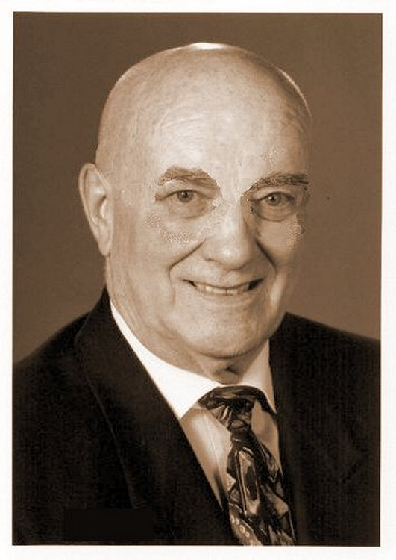Since volunteering at the Museum last May, Leonard Yarbrough has assumed the duties of webmaster and has updated our website to a much more informative and attractive rendition. The site now weaves Blount County history and heritage into the material presented to our viewers. The site now supports online purchases and payments, as well as providing access to some of the Museum’s archived materials.

Dr. Yarbrough is a retired NASA executive, and is an engineer by training; he also holds degrees from both Auburn and Alabama. Serving as editor and webmaster for several other sites, he is also a genealogist and amateur radio operator. He has three children, two dogs and 25 acres in the Rock Springs Community.