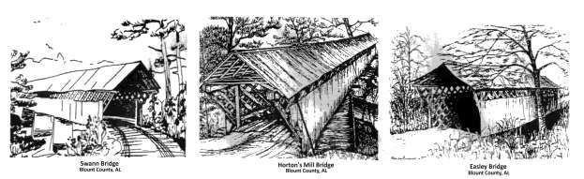
Blount County Historical Society
And Memorial Museum

The Blount County Historical Society cordially invites you to become a member. As the third oldest county historical society in Alabama, our mission is twofold: to help preserve the history of Blount County and to inform the public of the county’s rich heritage. The society also provides funding for the operation of the Blount County Memorial Museum. The society holds four (quarterly) meetings annually at the Blount County Memorial or at historical sites within the county. Each meeting features a guest speaker and presentation.

Membership includes a quarterly newsletter. Membership dues are $10.00
per member per year, payable to the Blount County Historical Society. For an additional $15.00 per year, access to Ancestry.com and Fold3.com is provided.
- - - - - - - - - - - - - - - - - - - - - - - - - - - - - - - - - - - - - - - - - - - - - - - - - - - - - - - - - -
Please clip and mail to:
Blount County Historical Society
P. O. Box 45
Oneonta, AL 35121
205-625-6905

Name: _________________________________________________________

Address:

City: State: Zip Code:

Amount Enclosed: $ ___________

Pay dues online at http://www.blountmuseum.org/paydues.html.

