Alabama Gen Society | 001
Amason | 002
Alexander | 003
Anderton | 004
Agricola­ | 005
Abercromby | 006
Armstrong | 007
Allgood | 008,009,013,014,018,416
Ash | 010

Anderson
Amberson Allred Arbuthnots Andersonville Askew
Bass
Blackburn Blakely Burgess· Brewer Billingsley Baker Battles
Blackwood | 025, 026, 038, 046, 047, 050 | 050A
Bailey | 027
Bishop | 028
Bynum 029 030 033 34 35 37 38 39 40 41 42
 | 386 059A
Box | 031
Blount | 032
Bartlett | 036
Brown | 049

011, 012, 0 12A
015, 016
017
Ol7A
017B
010A
019
020, 048
386
021
022, 59A
023
407
024

,43 44 45 059

s.:

&iin
386
386
051 052
053
061
060
058
057
056
056A
055
054
062 062A
063 067
069
066
0651\'?D
064 068.
070
070A
0708

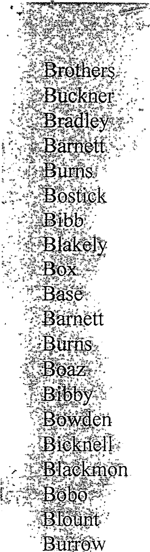Cowden Cannon Chapman Ca1vert
Cornelius ..:-·,:_ ::.
ChuEeh,·'; e0 ;l,Lffi,,. ;*,:,j' · ,.··.. -·.:;, ' Camp:W tl . ;: · ;·- Coo:ki::,:· ·. , .
Chiltri:e .s. -
' "'-
Cctti®;J ·
caG:Ii. {

$ -; : 1}. v t-
090 085 085A 88A 888
59A
081 092 093 012A
080 079 078 077 076 075 075A
089 074 087 072 072A
083
082
088
073
' 071
086

Coyle Copeland Cole
I Crump
084
084A
094, 094A 141
095, 386

Chambers | 096
Clements | 386
Cobb | 097

·Carnes
Chamblee Carmichael Collinsville Champion Carter Cumbest Cullwells
·Cummins
Cato Dickinson Davidson Deaver Daily
, Dearman/Deerman
Drennen Daily Darning Daves Duffy Ellis Epps Foust
·Feemster
Fe dley
098
098A
0988
098C
098D
98E,
99F
99G
407
99H
105 I 01
104 103
108 o'99
107
106
100 102
110
109
109A
386
Ill, 112, 112A,41 7
1128
113
114
115, 125, 124, 123, 122,

Coyle Copeland Cole Crump Chambers Clements Cobb
·Carnes Chamblee Carmichael Collinsville Champion Carter
Cum best
Cullwells Cummins Cato Dickinson Davidson Deaver Daily
Dearman/Deerman
Drennen Daily Dorning Daves Duffy Ellis Epps Foust
·Feemster
Fendley
084
084A
094, 094A I4I
095,386
096
386
097
098
098A
0988
098C
098D
98E,
99F
99G
407
99H.
1 05 Ib i
104 103
I08 099
107
106
100 102
110
109
I09A
386
111, 112, 112A,417
1128
113
114
115,125,124,123,122,

Frazier
'Faulkner
Foust
Flournoy Foster Fowler Foscue Fink Gibson Goffs Green
,Gamble
Gilley
Gilliland Galloway Graves Good Goodwin Glover
<@nren
'tilitl?t.ert
Gilmore Garrett Harp Hall
Huff m J::er
Harrtl>y
Hol-den Hawkins Hays Horsley Horton
116
405
117,118,405
119
120
121
121A
402
386
126
127
128
129
130, 136, 137, 137A, 386
131
132
133
134
135
138, 386
156, 386A
156A
1568, 156C, 1560
386
139
140,15'1, 405
141
142
143, 157, 158
158AB
144
145, 169

Hendricks Henderson Hallmark Harris
Hollingsworth.
,Harmony Humphreys Hood Hudson
Holt Handley Harvey Hassinger Hathorn. Hickman Hood
Hart Holcomb Hammond Harllee Hoenig Hendricks Hewitt Huie Hamilton Isbell Ingram Izard Jenkins Jordans Jackson Jones.
146
147
148, 155, 155A,370, ?70A, 395
149, 149A
150, 168, 172
152
153
154
159, 160
161, 161A, 188A, 392
162
163
164
165
166
167
168,..,168A
169
173 i
174, 175, 176
177
370
370
405
407
178
179, 180
181
182, 182A
183
184, 185, 186, 186A 0 12A
187, 188

Jernigan Johnson James Klein Kiag Keitfi
Kemp
&etLy
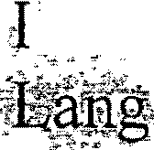. '.. ' -: >;a-11

tt}ve l;fffGlsey Lint1er
Lowe
talE.on | 200
Laft!0nts | 201
Lumpkin | 203,204,203.
Magna | 206
 | 386
 | 207
 | 208
Mathis | 209
Maples | 386
Martin | 210
Mead | 211
May | 212
McAnally | 213,214
McCay | 215
McClendon | 216,217,386
McCray | 218
McCullough | 219,220,221
McPherson | 407

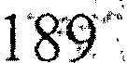. .
3s:6, a ·6f:\
18.9A-
J;9tr"
.) ..
. ,:1• ·- <f:\'"'1 •
1, 9 .
f--Llj 2(:
192'/ ....l·9• 4-
415
412,413
202
4DT:\ .
390;393
195, 197
196
. 1 9

Mize Millican Moody Moore Moon Morgans Mooris Morton

Murphree

Neely NeSmith Nation O'Bannon Odenkirchen Odom Odenville Otelco Owsley Palmer Powell Parham Parker
Paul
Phillips Pitt Poellnitz Puckett Poinsett Posey Poyntz

Newsome 419
222
223,224
225,226
227
228
229
230
231,232,234,235

236,237,238,239,240,241,242,243,244
245,246,247,248,386
249, 249A
250
251
252
253
386
254
255
256,257, 258
259,260
59A, 598
261
262
263,264
265,266,386
267
268
403
269
270, 271
272

·Preston Price Pullen
Qa s<lale i!tatliff "Reed
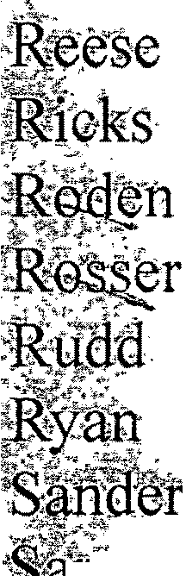:J§®id

s
. ''t Tit
Sa¥"'a"l"g' e
Se le
Setl5 Ft
- 1le:n ;-
.O'<";
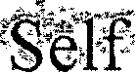
s-e:w.€H
Shaf11
Si1 -­ S4l"tr6 :ok SloccR ·
S- Y
Smith | 303,304,305,306,387
Sims | 418
Snell | 307
Stamps | 308
Stanfiled | 309,310
Steele | 311,312

273
27-4,2)5,276,277
278':._
.l -- -:0'
2'79:
18 i-
2S1 ·282

2 -' 284, 285 J D
28<5:. .
·-281 - -
, · . ""
288"
289
59A
290 .-
3 !-.
397
291
292
293
294,294A
295, 295A,405
296
297
298
299,300
301
302

Stephens
Sterling
Susan Moore "Stringer Swann
Tate
Tabb Terrell Terry Telford
Templeman
Thomas Thomason Thornhill Tidwell Tilsley Tolbert Trader Tubb Turner
Village Springs
Vaughn Veal Yeild Yielding Young Whitley Woodard Waldrop Ware Waid Walker.
Yarbrough 421
313
314
315
316
317,318,319
386
320
321
322,323
324
325
326,327,328,329
330
331
332,333
334
386
335
336
337,338
339
340
341
341A
342
343, 420
400
398
390
391
344
345,,346,347'386

Ward Washburn Wilder Warner Weaver Weeks Weems Wester Whited Wigington Wilemon Witts WiHard
: ittmeier
Wis<ion
Williams
·Wil-son
·wbodard
:Wtl ten
Wren
. t.rgfit
·wyw
Waugh
St0ry ·of Alabama
Hj t0ty of Alabama
34'g;

. · ..
J
350·
35 i·
. 3 '2"
·:..5::'1· ··:,·
*...,., ·;,.
-,,. ",!,·. """:
i ie11:·

;4-J:Jn.;J
3: .5; 356
357
3:58.,359
'3 60
3·6·1' 369
362
363
364
365,366,367,368
370,371
372
373
374
375,410,411
376
386
378,379,380,381,382
383,384,385

